Hello Tabular

Create a dataset, **Select an import file from Cloud Storage** and use cloud-ml-tables-data/bank-marketing.csv

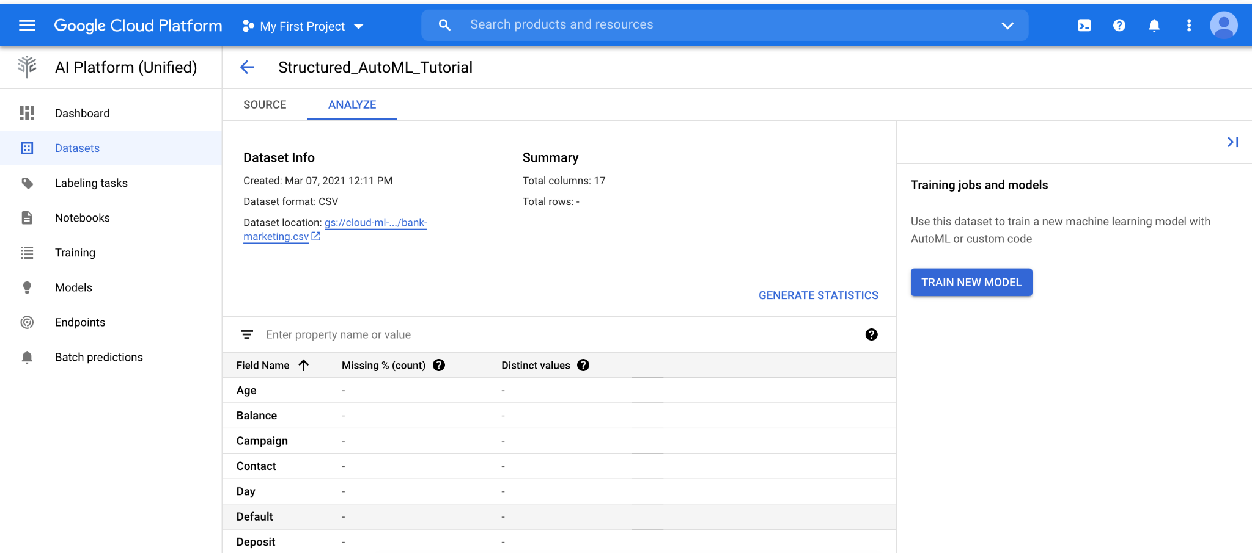

**Generate statistics**

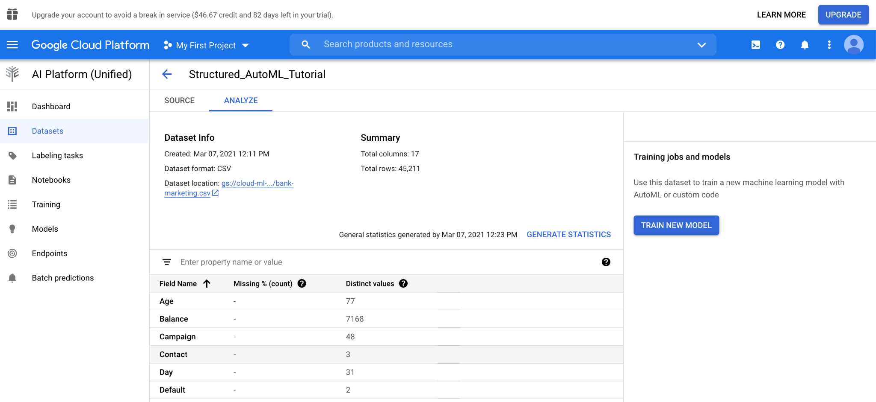

**Train new model**

Select Deposit for the target column, and Classification for the objective.

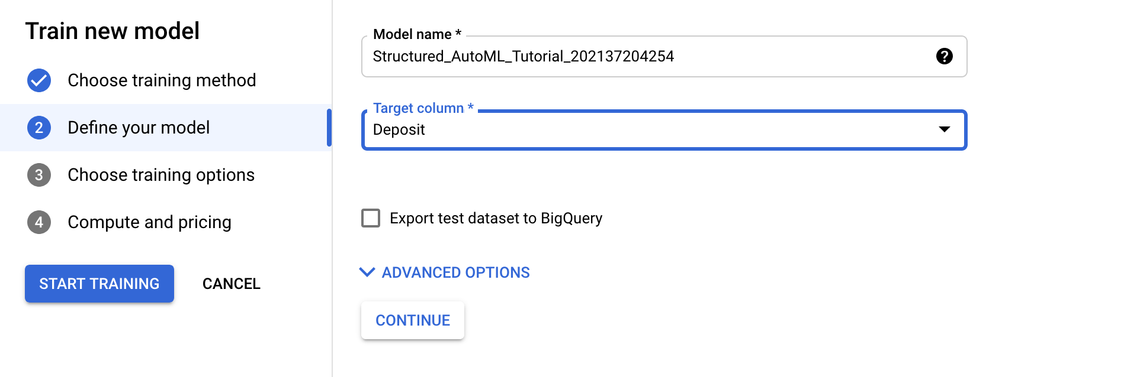

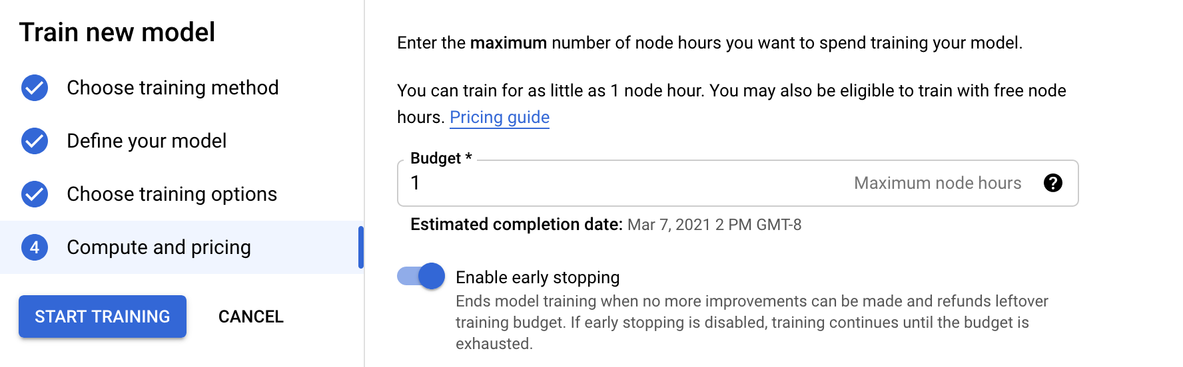

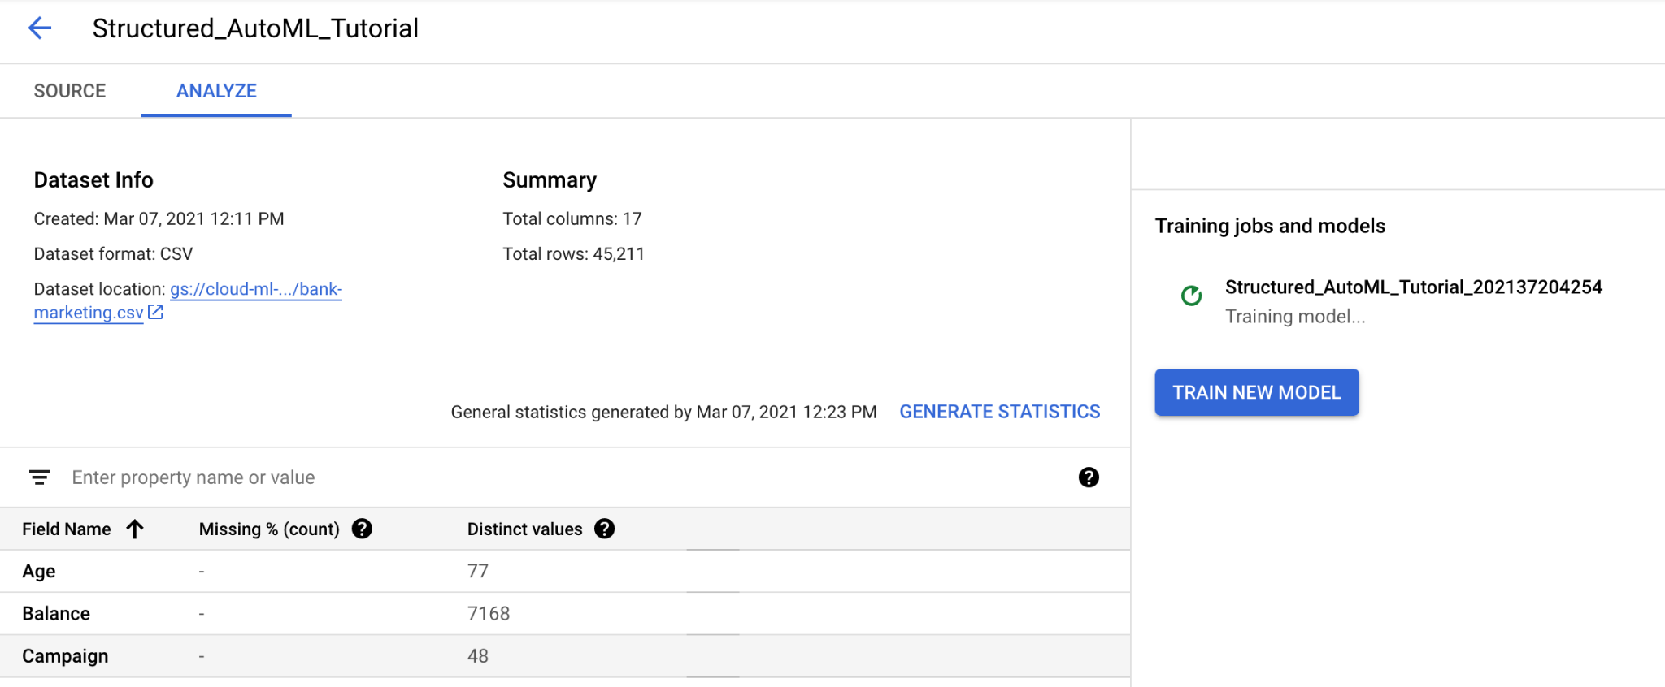

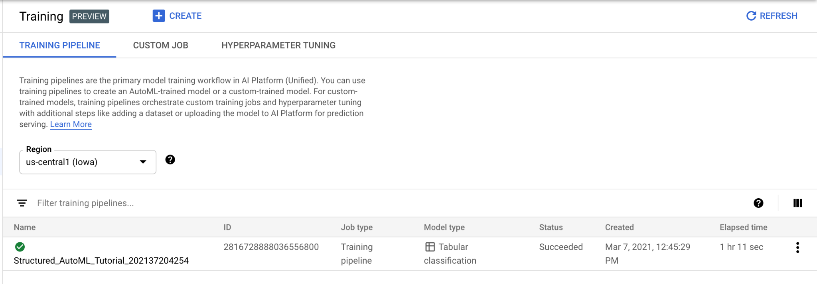

**Deploy and test**

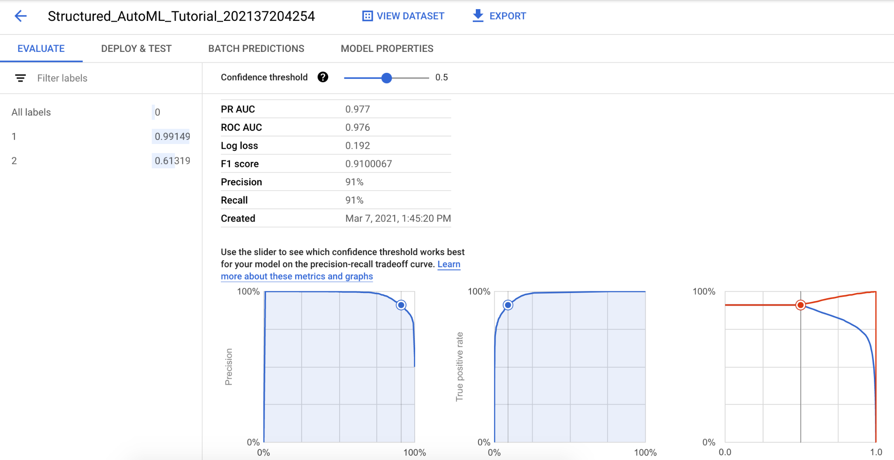

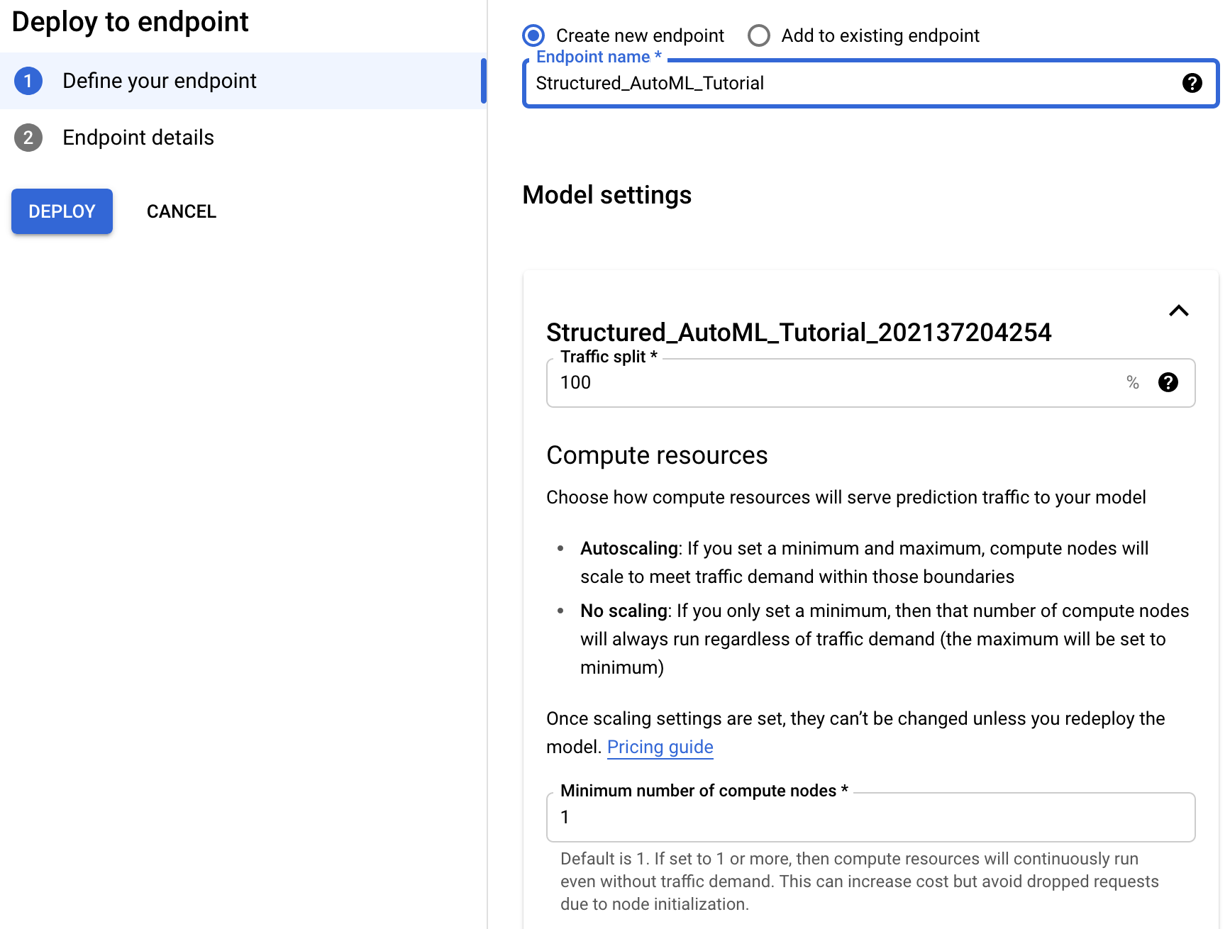

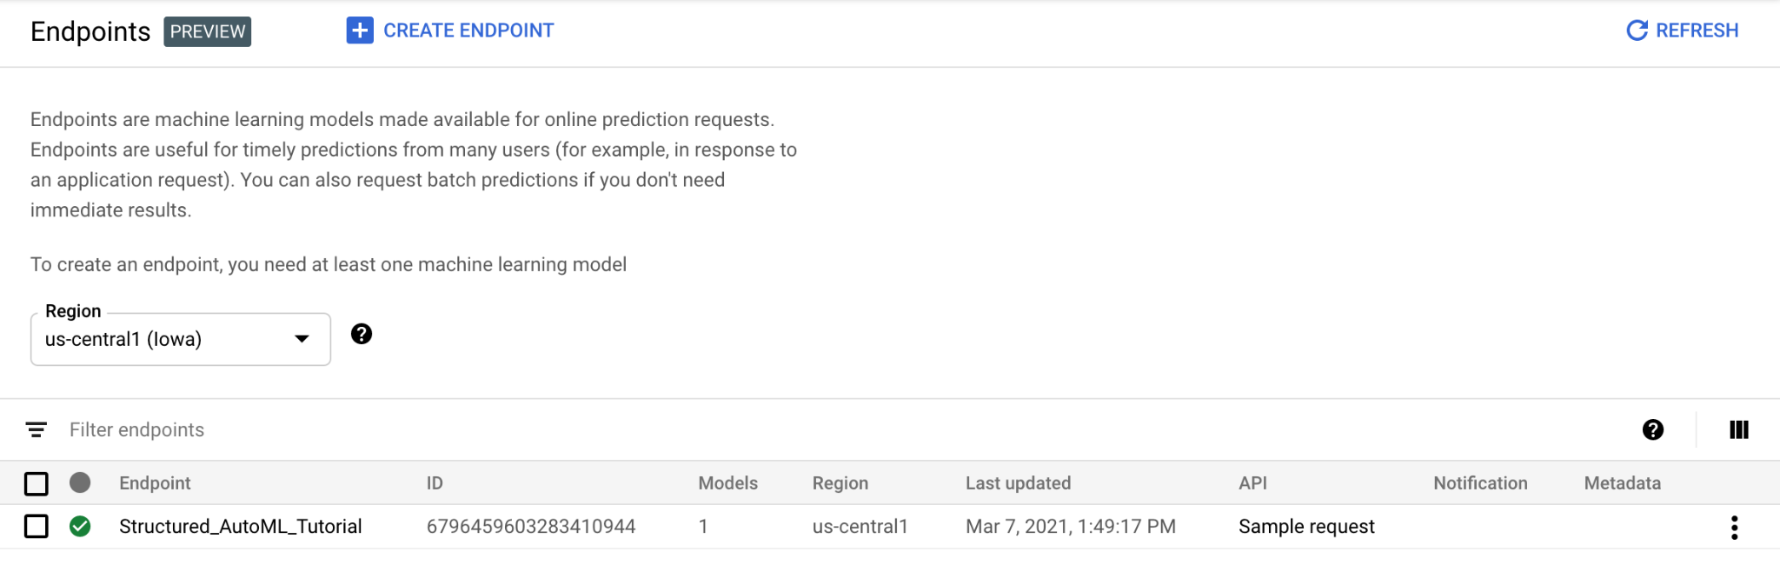

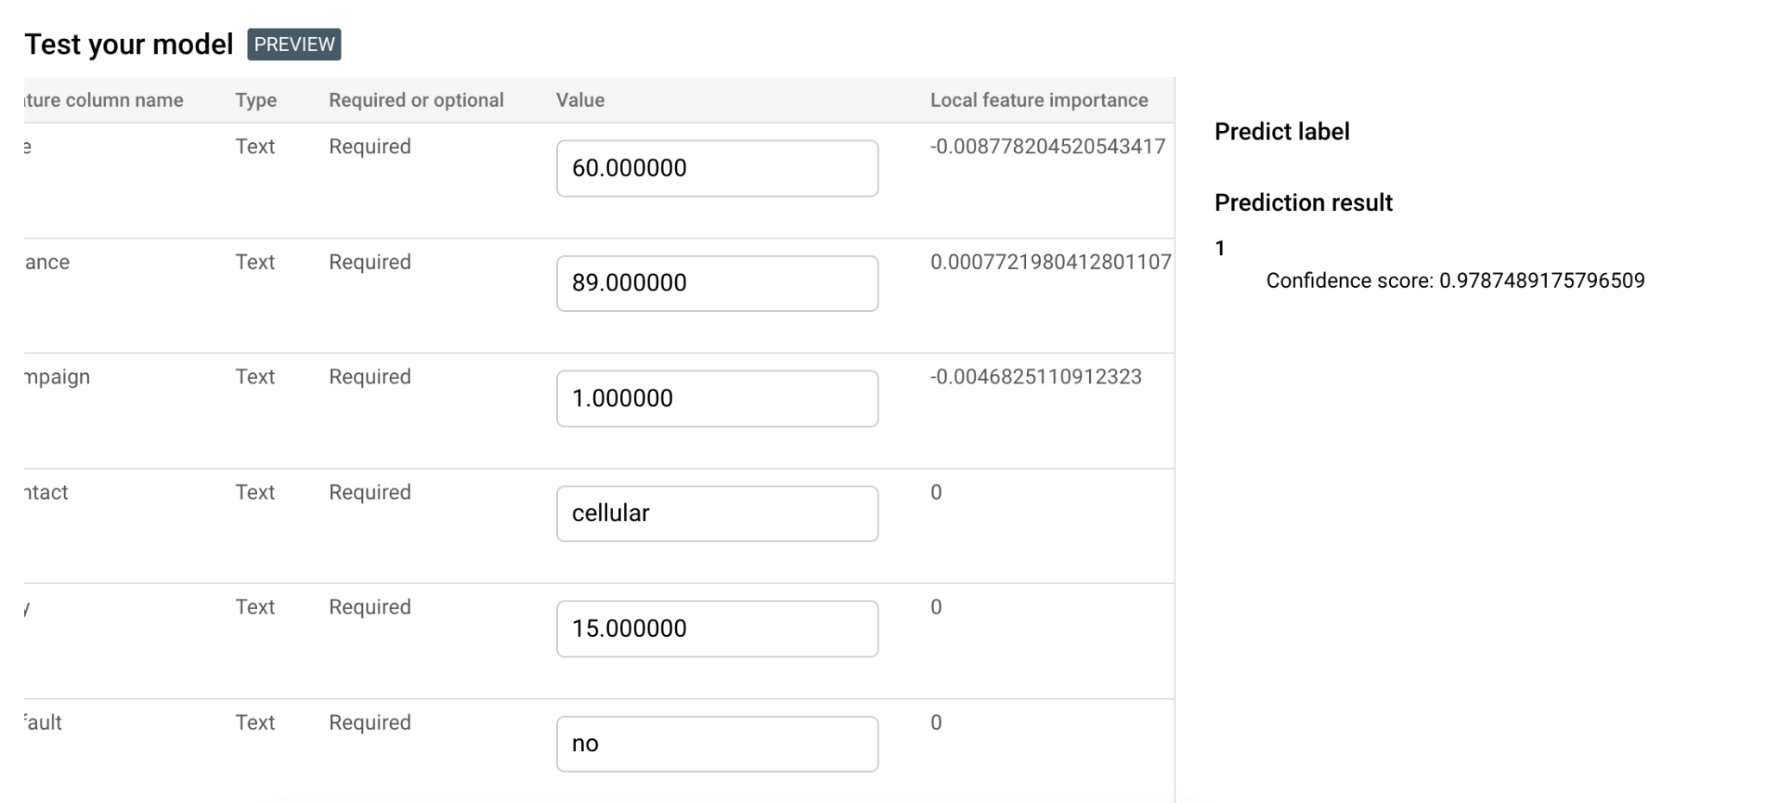

For this model, a prediction result of 1 represents a negative outcome—a deposit is not made at the bank. A prediction result of 2 represents a positive outcome—a deposit is made at the bank.

Cleanup

Undeploy model and remove endpoint

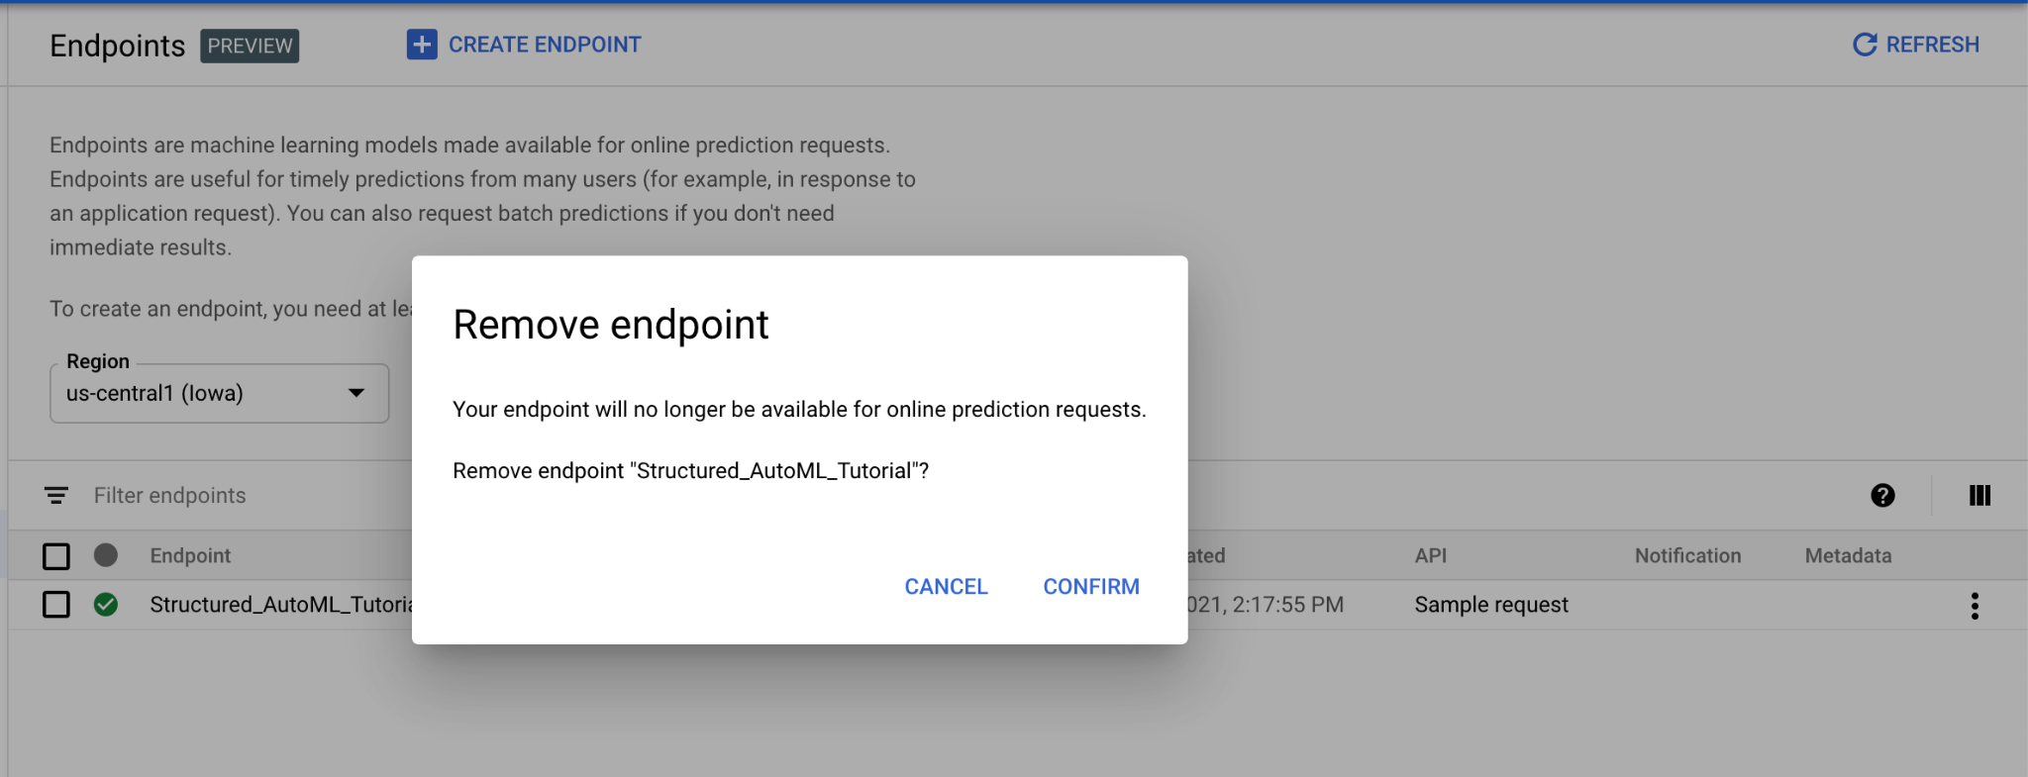

Delete model and dataset